Pairing the Socket Mobile 7Ci

(Please allow the socket mobile to charge for a few hours before usage)

- Power on the Socket Mobile
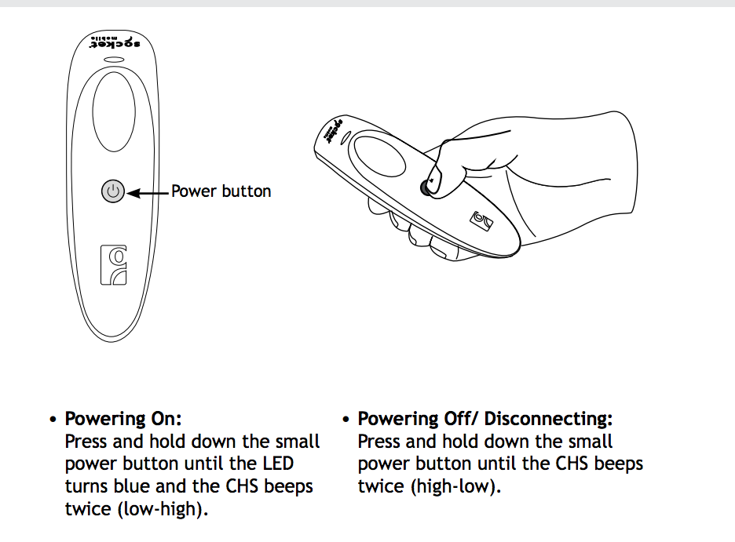
- If the barcode is already ‘connected/paired’ to your iPad then please disconnect it:
- Go to ‘Settings’ on your iPad
- Go to ‘Bluetooth’
- Touch on the ‘i’ (info) icon next to the scanner that is connected
- Touch on ‘Disconnect’ or ‘Forget the device’

- Turn on iPad’s Bluetooth.
- Go to ‘Settings’ on your iPad’
- Go to ‘Bluetooth’
- Turn off ‘Bluetooth’ switch
- Now scan on the image below to perform a “Factory Reset” (If successful you will hear 5-7 beeps)

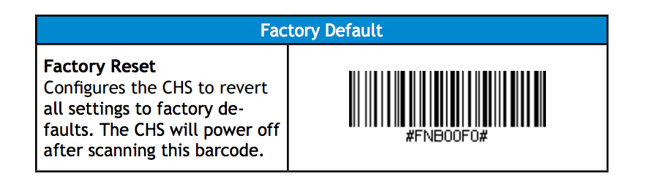

- There are 2 different types of modes (iOS and HID). Default is HID but iOS is highly recommended. Scan the iOS barcode in the image below. If the scan is successful, you will be able to hear 5-7 different beeps.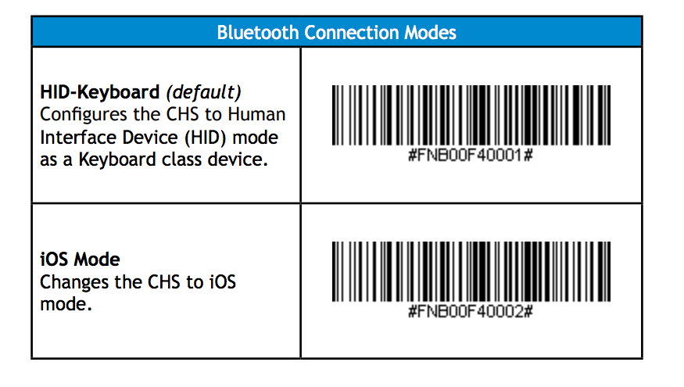

- Go to ‘Settings’ on the home screen of your iPad
- Verify that Bluetooth is enabled
- If the scanner is off, then please power it on as displayed on the image in step #1
- Tap on “Socket CHS [XXXXXXX] to connect it to your iPad
- Open the SalesVu point of sale (POS) software
- Touch on the ‘Settings’ (gear) icon
- Touch on ‘Manage Barcode Scanner’
- Touch on ‘Socket Scanner’ (It is not necessary to scan the image as this was done earlier)
- Touch on ‘Done’
- Now you will be able to scan the UPC/barcodes through the SalesVu POS

