Lane 3000 Terminal Setup (For Worldpay (Vantiv) Processor)
Please Note: The Lane 3000 is a networked payment device currently available for Vantiv customers only. This reader supports swipe, chip, and contactless (e.g. Apple Pay, Google Pay) payment methods. This device is used in Ethernet (network) mode. Each iPad must use its own reader if it is intended to take card payments. The reader cannot be used with multiple iPads.

Section 1. Setting up the hardware

- The cord of the card reader (Lane 3000) will have an Ethernet plug. Plug this into an open port of your wireless router or any Ethernet port available.
- Plug the power cord into an outlet and the card reader will automatically turn on.

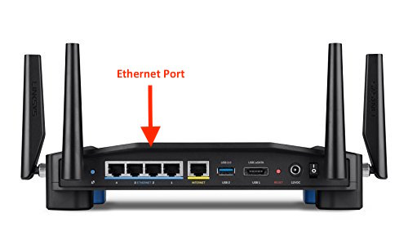

_________________________________________________________________________________

Section 2. Retrieving the IP address on the Lane 3000.

- Once the “Unifled Payment Platform” screen appears, quickly touch on the ‘downward’ button until you can see the IP address at the bottom. (Please note that this screen will change quickly)

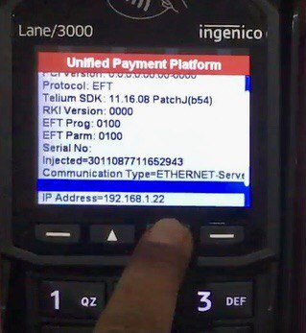

- If you are not able to record down the IP in time, hold down the “Yellow and #” button for 3 seconds to reboot and try again.

Section 3. Setting up the POS with the Lane 3000

- Open the SalesVu POS app on your iOS device (iPad)
- Touch on the ‘Settings’ icon
- Touch on ‘More Settings’
- Enter the IP address into the “Terminal IP” field
- Touch outside of the screen to get back to the POS

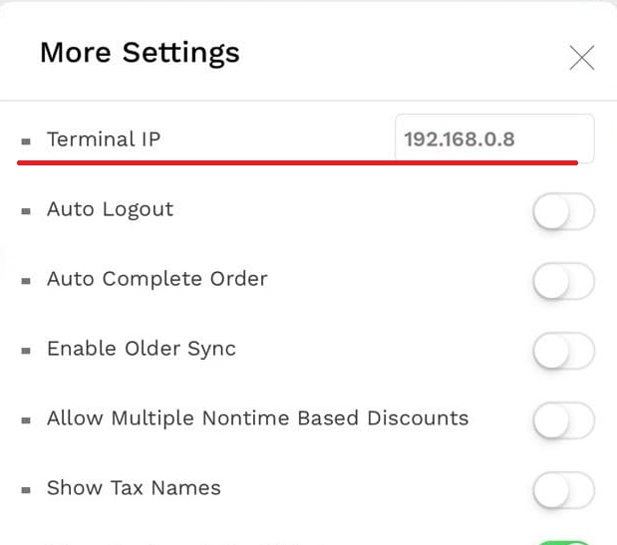
_________________________________________________________________________________

Section 4. Selecting Lane 3000 as card reader

- Touch on ‘Settings’ icon
- Touch on ‘Not Selected’ next to ‘Card Readers’
- Select ‘Lane 3000’ option

